Alonso_Project 2 Deliverable

Martin Alonso

June 27, 2018

# 1. Summary and Business Case

This project looks to create a pitch usage database that tracks the types of pitches thrown by professional baseball players as well as the events surrounding their decisions to use certain pitches, while also monitoring the movement of these pitches, starting from the release point out of the pitchers hand up to the moment the pitch reaches the plate. The importance of creating such a database will let us better understand the physics behind each pitch thrown by major league pitchers, as well as understand the effects of pitch sequencing and game theory regarding individual pitcher-batter matchups and decisions made.  
As such, we first need to track every game that has been played. Every game will have multiple events, but each event must be assigned to one game. Each event will involve two teams, a fielding team with a pitcher and a batting team with a batter involved. Only one batter and one pitcher can be involved in one single event, though there can be multiple separate events involving the same pitcher and batter. Because of this, each event must occur sequentially, tracking the inning, outs, plate appearance, pitch used, pitch of the sequence, result of the pitch (ball, foul, or strike), outcome (strike out, hit, walk, etc.), men on base (first, second, third), the score, and the plate appearance of the inning. This must be done for every pitch thrown in every single game.  
Each pitch must be assigned to a pitch type and each pitch can only have one pitch type, but there can be multiple pitches with different pitch types. Each pitch must also be related to a single pitcher, though a pitcher can throw multiple pitches of different pitch types. Each pitch thrown must also be linked to one and only one event. However, the pitch must also be linked to the pitch of the next event, so we can analyze pitch sequencing. Each pitch within the first event must have a distinct release point, trajectory, and movement (both on the x and z plane). Likewise, each pitch will end in one result, but many results can be traced backed to each pitch thrown.  
On the player side, each game will feature players from two teams. Only two teams may play in any single game, and at least nine players from each team must be present. However, if the home team is from the American League, at least ten players will have to appear (given the DH-rule of the American League.) We must also know, for each team, what position each player has on the field (using baseball’s position guide, 1 through 10.) Each position must be played by a player on each team, but, given pitching changes, pinch hitters, pinch runners, defensive replacements, and injuries, many players could end up playing a single position in any given game.

# 2. Conceptual Model

The database will need at least six tables that will work together to provide the necessary information for each plate appearance and every pitch that has been thrown throughout the seasons.  
The Game table will provide the GameID, the date a game was played, and the Home and Away teams.  
Both the HomeTeamID and the AwayTeamID will be fed from the Team table, which will have the TeamID, TeamCity, TeamName, and LeagueID, identifying the different teams that have played.  
The GameID will work as the first foreign key that will help identify the different events that have occurred within a game. These events will be found in the Events table. Within this table, we will have the pitcherID, batterID, inning, half_inning (top or bot), and plate_appearance, provinding us with the context of every plate appearance that has occurred within the game. Similarly, the event will also have the pitchID of every pitch thrown in the plate appearance, along with the pitch_type, the pitch_of_pa, the result of the pitch (whether it was a ball or a strike), and the outcome (which will be ball and strike for every pitch that doesn’t end the plate appearance; for the rest, it will show what happened). The events table will also show, through the use of boolean values, whether there were men on first, second, or third, the count (by adding the previous pitches thrown), the outs, and the scores for both home and away teams.  
Both the pitcherID and batterID will be linked to the Player table, which will provide the information for each player: his first_name, last_name, birth_date, height_in (in inches), weight_lbs (in pounds), TeamID (which will be linked to the Team table), season, and positionID for the main position the player played.  
The positionID will be linked to the Position table where the names of each position will be taken from. PositionID will be an integer that goes from one to ten, using the standard notation for every baseball position (1 – pitcher, 2 – catcher, 3 – first base, 4 – second base, 5 – third base, 6 – shortstop, 7 – leftfield, 8 – centerfield, 9 – rightfield, 10 – designated hitter).  
Going back to the events table, this table also features pitchID, which is a foreign key that will merge the Event table to the Pitch table. Within the Pitch table, we will find the pitchID and the pitch_type of the pitch thrown. We will also find the pitcherID (which will link from the Player table) and the eventID (which will link from the Event table). Finally, we will have the information regarding the movement of the pitch: release_point, velocity, x_movement, z_movement, max_plate_dist, max_plate_time, and next_pitch (which will be the pitchID of the next pitch thrown in the sequence). This will help us identify pitch sequencing used by the different pitchers.

# 3. Normalization

Starting with the Game table, we find that this is already in 3NF. We have the example data looking as follows:

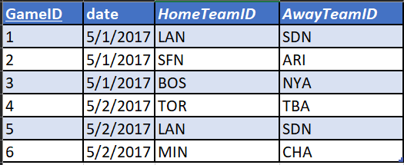

We end with the normalized form: Game (GameID, date, HomeTeamID, AwayTeamID)

Similarly, the Team, Player, and Position tables are also in 3NF:

Team

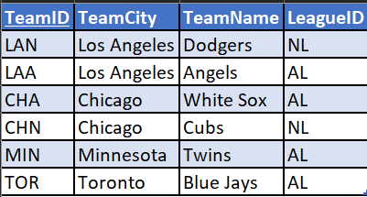

Player

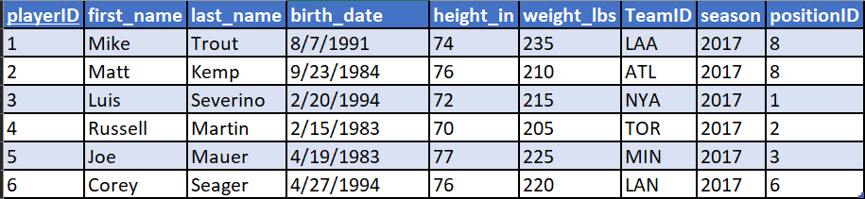

Position

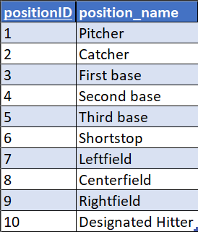

These three tables are in the form:

Team (TeamID, TeamCity, TeamName, LeagueID)

Player (playerID, first_name, last_name, birth_date, height_in, weight_lbs, *TeamID*, season, *positionID*)

Position (positionID, position_name)

***

The Event and Pitch tables, however, are not in 3NF, so we must convert them. Starting with the Event table, it currently sits like this:

Event (eventID, *GameID*, *pitcherID*, *batterID*, inning, half_inning, plate_appearance, pitch_of_pa, *pitchID*, pitch_type, result, outcome, runner_1b, runner_2b, runner_3b, balls, strikes, outs, home_score, away_score)

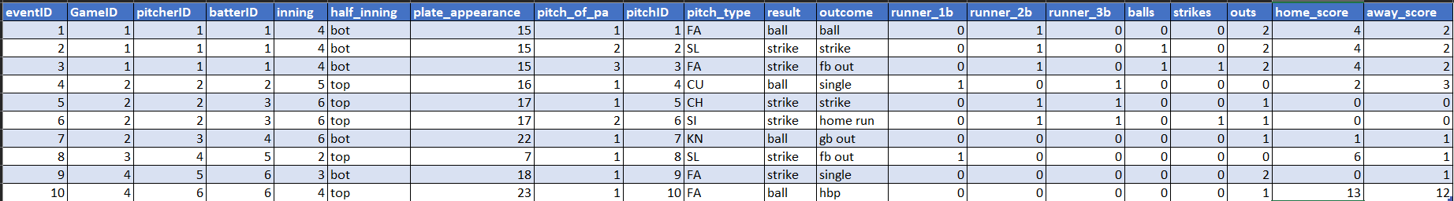

Looking over the table, the two principal dependencies that I can find are both the eventID column and the pitchID column.

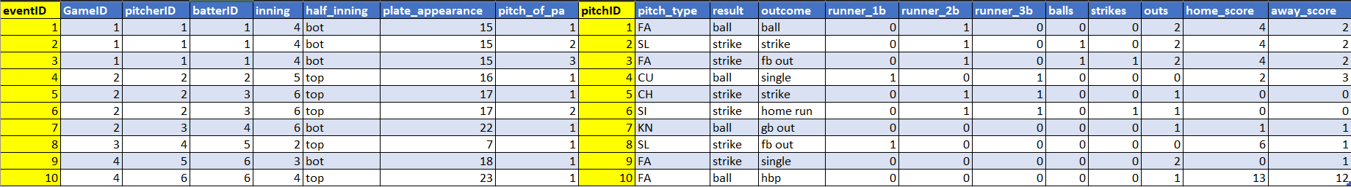

So, I’ll create a new table Pitch_event to house the data for every pitch event:

Pitch_event (pitchID, pitch_of_pa, pitch_type, result, outcome, balls, strikes)

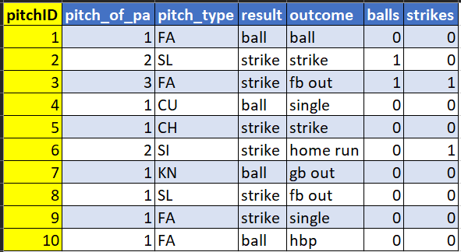

Meanwhile, the Event table looks something like this:

Event (eventID, *GameID*, *pitcherID*, *batterID*, inning, half_inning, plate_appearance, *pitchID*, runner_1b, runner_2b, runner_3b, outs, home_score, away_score)

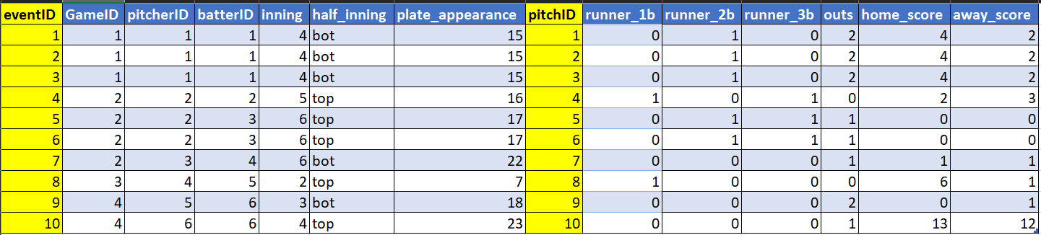

Looking at the table, it still feels that it is not completely in 3NF. So, I’ve decided to create a new table called Plate_Appearance that gives the basic details of the plate appearance:

Plate_Appearance (plate_appearance_id, *pitcherID*, *batterID*, inning, half_inning, plate_appearance, runner_1b, runner_2b, runner_3b, outs, home_score, away_score)

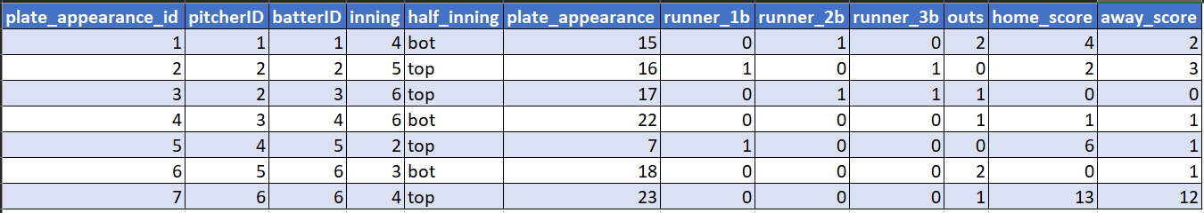

And, finally, the Event table looks like this: Event (eventID, *GameID*, *plate_appearance_id*, *pitchID*)

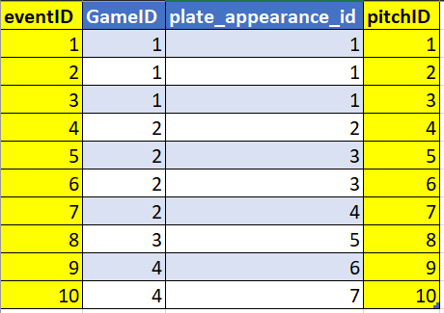

***

The last table that needs to be converted to 3NF is the Pitch table. Currently, it looks like this:

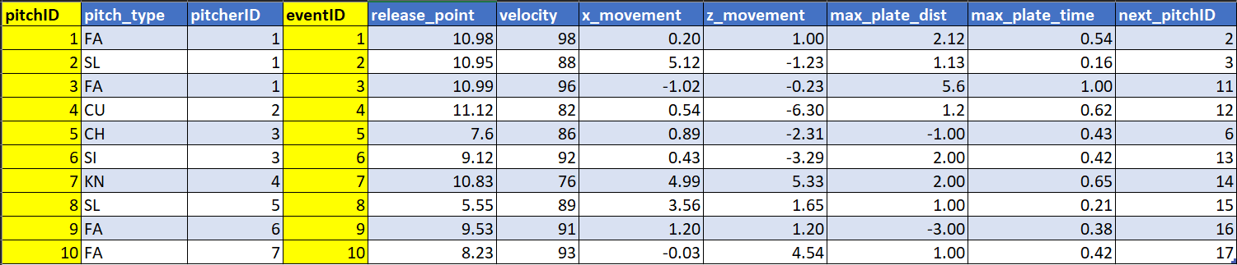

Because we’re focusing on pitch tracking data here, there is really no other way to identify the pitch data by any other way that isn’t related to the pitchID, the eventID, or the pitcherID. Since the eventID is already being tracked in the Event table, which is connected to the Pitch table via pitchID, then we could remove this column. Similarly, the pitcherID is also present in the Plate_Appearance table, which can be linked to the Pitch table via the Event table. So, we could also get rid of the pitcherID column, leaving us with the following table and 3NF:

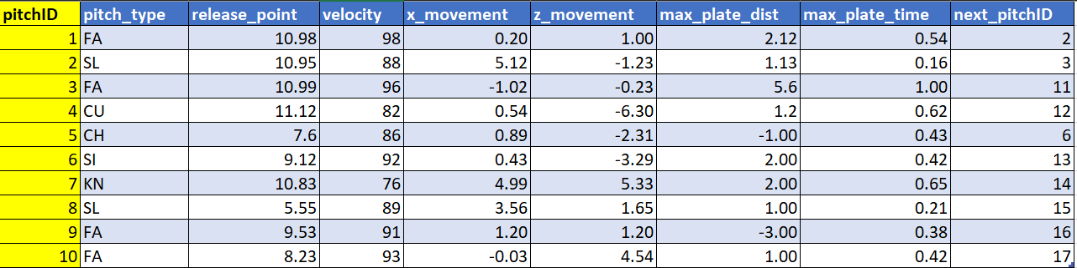

Pitch (pitchID, pitch_type, release_point, velocity, x_movement, z_movement, max_plate_dist, max_plate_time, next_pitchID)

The final diagram would look like this:

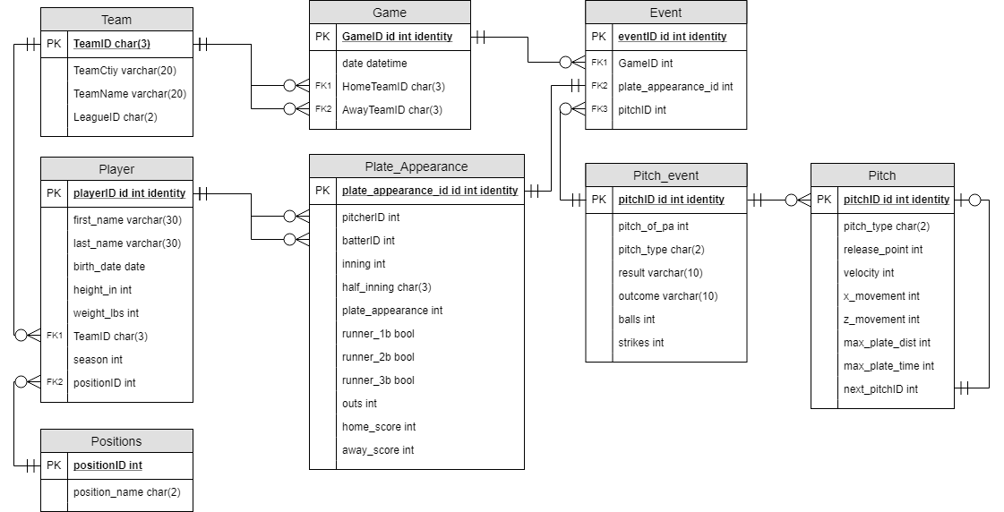

# 4. Physical Database Design

/*  
 Author: Martin Alonso  
 Course: IST659 Project  
 Term: April 2018  
 */  
   
 --Create the League table  
 CREATE TABLE League (  
 --Columns for the League table  
 LeagueID char(2) not null,  
 LeagueName char(30) not null,  
 CONSTRAINT PK_League PRIMARY KEY (LeagueID)  
 );  
 --End Creating the League table   
   
 --Create the Team table  
 CREATE TABLE Team (  
 --Columns for the Team table  
 TeamID char(3) not null,  
 TeamCity varchar(20) not null,   
 TeamName varchar(20) not null,  
 LeagueID char(2) not null,  
 --Constraints on the Team table  
 CONSTRAINT PK_Team PRIMARY KEY (TeamID),  
 CONSTRAINT FK1_Team FOREIGN KEY (LeagueID) REFERENCES League(LeagueID)  
 );  
 --End Creating the Team table  
   
 --Create the Game table  
 CREATE TABLE Game (  
 --Columns for the Game table  
 GameNumber int identity,   
 GameID char(25) not null,  
 Game_Date datetime not null,   
 HomeTeamID char(3) not null,  
 AwayTeamID char(3) not null,  
 --Constraints on the Game table  
 CONSTRAINT PK_Game PRIMARY KEY (GameID),  
 CONSTRAINT FK1_Game FOREIGN KEY (HomeTeamID) REFERENCES Team(TeamID),  
 CONSTRAINT FK2_Game FOREIGN KEY (AwayTeamID) REFERENCES Team(TeamID)  
 );  
 --End Creating the Game table  
   
 --Create the Positions table  
 CREATE TABLE Positions (  
 --Columns for the Positions table  
 positionID int not null,  
 position_short char(2) not null,  
 position_name char(20) not null,  
 --Constraints on the Positions table  
 CONSTRAINT PK_Positions PRIMARY KEY (positionID)  
 );  
 --End Creating the Positions table  
   
 --Create the Player table  
 CREATE TABLE Player (  
 --Columns for the Player table  
 playerID int identity,   
 first_name varchar(30) not null,   
 last_name varchar(30) not null,  
 birth_date date not null,  
 height_in int,  
 weight_lbs int,  
 TeamID char(3),  
 season int,   
 positionID int,  
 --Constraints on the Player table  
 CONSTRAINT PK_Player PRIMARY KEY (playerID),  
 CONSTRAINT FK1_Player FOREIGN KEY (TeamID) REFERENCES Team(TeamID),  
 CONSTRAINT FK2_Player FOREIGN KEY (positionID) REFERENCES Positions(positionID)  
 );  
 --End Creating the Player table  
   
 --Create the Plate_Appearance table  
 CREATE TABLE Plate_Appearance (  
 --Columns for the Plate_Appearance table  
 plate_appearance_id int identity,   
 GameID char(25) not null,  
 pitcherID int not null,   
 batterID int not null,  
 inning int not null,  
 half_inning char(3) not null,  
 plate_appearance int not null,  
 runner_1b bit,  
 runner_2b bit,   
 runner_3b bit,  
 outs int not null,   
 home_score int not null,  
 away_score int not null,  
 --Constraints on the Plate_Appearance table  
 CONSTRAINT PK_Plate_Appearance PRIMARY KEY (plate_appearance_id),  
 CONSTRAINT FK1_Plate_Appearance FOREIGN KEY (GameID) REFERENCES Game(GameID),  
 CONSTRAINT FK2_Plate_Appearance FOREIGN KEY (pitcherID) REFERENCES Player(playerID),  
 CONSTRAINT FK3_Plate_Appearance FOREIGN KEY (batterID) REFERENCES Player(playerID)  
 );  
 --End Creating the Plate_Appearance table  
   
 --Create the Pitch_event table  
 CREATE TABLE Pitch_event (  
 --Columns for the Pitch_event table  
 pitchID int identity,   
 GameID char(25) not null,  
 plate_appearance_id int not null,  
 pitch_of_pa int not null,   
 pitch_type char(2) not null,  
 result varchar(10) not null,  
 outcome varchar(20),  
 balls int not null,  
 strikes int not null,  
 play_description varchar(100),  
 --Constraints on the Pitch_event table  
 CONSTRAINT PK_Pitch_event PRIMARY KEY (pitchID),  
 CONSTRAINT FK1_Pitch_event FOREIGN KEY (GameID) REFERENCES Game(GameID),  
 CONSTRAINT FK2_Pitch_event FOREIGN KEY (plate_appearance_id) REFERENCES Plate_Appearance(plate_appearance_id)   
 );  
 --End Creating the Pitch_event table  
   
 --Create the Pitch_type table  
 CREATE TABLE Pitch_type (  
 --Columns for Pitch_type table  
 Pitch_type char(2) not null,   
 Pitch_name char(20) not null,  
 --Constraints on the Pitch_type table  
 CONSTRAINT PK_Pitch_type PRIMARY KEY (Pitch_type)  
 );  
 --End Creating the Pitch_type table  
   
 --Create the Pitch table  
 CREATE TABLE Pitch (  
 --Columns for the Pitch table  
 pitchID int not null,  
 pitch_type char(2) not null,  
 release_point float not null,   
 velocity float not null,  
 x_movement float not null,  
 z_movement float not null,  
 max_plate_dist float not null,  
 max_plate_time float not null,  
 next_pitchID int not null,  
 --Constraints on the Pitch table  
 CONSTRAINT PK_Pitch PRIMARY KEY (pitchID),  
 CONSTRAINT FK1_Pitch FOREIGN KEY (pitchID) REFERENCES Pitch_event(pitchID),  
 CONSTRAINT FK2_Pitch FOREIGN KEY (pitch_type) REFERENCES Pitch_type(Pitch_type)  
 );  
 --End Creating the Pitch table  
   
 /*  
 drop table pitch;  
 drop table pitch_type;  
 drop table Pitch_event;  
 drop table Plate_Appearance;  
 drop table Player;  
 drop table Positions;  
 drop table Game;  
 drop table Team;  
 drop table League;  
 */  
   
 /*Removed GameEvent table as it was the same as Pitch_event table sans the GameID column.   
 Game, Pitch, and Plate_Appearance now reference each other without GameEvent table.*/

# 5. Data Creation

--Insert data into League table   
 INSERT INTO League  
 (LeagueID, LeagueName)  
 VALUES  
 ('AL', 'American League'),  
 ('NL', 'National League');  
   
 --Verify that the data has been inserted successfully  
 SELECT * FROM League;  
   
 --Insert Team data into Team table  
 INSERT INTO Team  
 (TeamID, TeamCity, TeamName, LeagueID)  
 VALUES  
 ('ARI', 'Arizona', 'Diamondbacks', 'NL'),  
 ('ATL', 'Atlanta', 'Braves', 'NL'),  
 ('BAL', 'Baltimore', 'Orioles', 'AL'),  
 ('BOS', 'Boston', 'Red Sox', 'AL'),  
 ('CHA', 'Chicago', 'White Sox', 'AL'),  
 ('CHN', 'Chicago', 'Cubs', 'NL'),  
 ('CIN', 'Cincinnati', 'Reds', 'NL'),  
 ('CLE', 'Cleveland', 'Indians', 'AL'),  
 ('COL', 'Colorado', 'Rockies', 'NL'),  
 ('DET', 'Detroit', 'Tigers', 'AL'),  
 ('HOU', 'Houston', 'Astros', 'AL'),  
 ('KCA', 'Kansas City', 'Royals', 'AL'),  
 ('LAA', 'Los Angeles', 'Angels', 'AL'),  
 ('LAN', 'Los Angeles', 'Dodgers', 'NL'),  
 ('MIA', 'Miami', 'Marlins', 'NL'),  
 ('MIL', 'Milwaukee', 'Brewers', 'NL'),  
 ('MIN', 'Minnesota', 'Twins', 'AL'),  
 ('OAK', 'Oakland', 'Athletics', 'AL'),  
 ('PHI', 'Philadelphia', 'Phillies', 'NL'),  
 ('PIT', 'Pittsburgh', 'Pirates', 'NL'),  
 ('NYA', 'New York', 'Yankees', 'AL'),  
 ('NYN', 'New York', 'Mets', 'NL'),  
 ('SDN', 'San Diego', 'Padres', 'NL'),  
 ('SEA', 'Seattle', 'Mariners', 'AL'),  
 ('SFN', 'San Francisco', 'Giants', 'NL'),  
 ('SLN', 'St. Louis', 'Cardinals', 'NL'),  
 ('TBA', 'Tampa Bay', 'Rays', 'AL'),  
 ('TEX', 'Texas', 'Rangers', 'AL'),  
 ('TOR', 'Toronto', 'Blue Jays', 'AL'),  
 ('WAS', 'Washington', 'Nationals', 'NL');  
   
 --Verify that the data has been inserted  
 SELECT * FROM Team;  
   
 --Insert data into Game table  
 INSERT INTO Game  
 (GameID, Game_Date, HomeTeamID, AwayTeamID)  
 VALUES  
 /*Opening Day games.   
 PIT @ DET and WAS @ CIN not included on account of games being postponed.*/  
 ('2018_03_29_MIA_CHN_0', '2018-03-29', 'MIA', 'CHN'),  
 ('2018_03_29_NYN_SLN_0', '2018-03-29', 'NYN', 'SLN'),  
 ('2018_03_29_BAL_MIN_0', '2018-03-29', 'BAL', 'MIN'),  
 ('2018_03_29_TEX_HOU_0', '2018-03-29', 'TEX', 'HOU'),  
 ('2018_03_29_TOR_NYA_0', '2018-03-29', 'TOR', 'NYA'),  
 ('2018_03_29_TBA_BOS_0', '2018-03-29', 'TBA', 'BOS'),  
 ('2018_03_29_OAK_LAA_0', '2018-03-29', 'OAK', 'LAA'),  
 ('2018_03_29_SDN_MIL_0', '2018-03-29', 'SDN', 'MIL'),  
 ('2018_03_29_ATL_PHI_0', '2018-03-29', 'ATL', 'PHI'),  
 ('2018_03_29_KCA_CHA_0', '2018-03-29', 'KCA', 'CHA'),  
 ('2018_03_29_LAN_SFN_0', '2018-03-29', 'LAN', 'SFN'),  
 ('2018_03_29_SEA_CLE_0', '2018-03-29', 'SEA', 'CLE'),  
 ('2018_03_29_ARI_CLE_0', '2018-03-29', 'ARI', 'COL');  
   
 --View Game table  
 SELECT * FROM Game;  
   
 --Insert data into Positions table  
 INSERT INTO Positions  
 (positionID, position_short, position_name)  
 VALUES  
 ('1', 'P', 'Pitcher'),  
 ('2', 'C', 'Catcher'),  
 ('3', '1B', 'First Base'),  
 ('4', '2B', 'Second Base'),  
 ('5', '3B', 'Third Base'),  
 ('6', 'SS', 'Shortstop'),  
 ('7', 'LF', 'Leftfield'),  
 ('8', 'CF', 'Centerfield'),  
 ('9', 'RF', 'Rightfield'),  
 ('10', 'DH', 'Designated Hitter');  
   
 --View Positions table  
 SELECT * FROM Positions;  
   
 --Insert data into Player table  
 INSERT INTO Player  
 (first_name, last_name, birth_date, height_in, weight_lbs, TeamID, season, positionID)  
 VALUES  
 --MIA Opening Day lineup (only starting 9; no relievers, pinch hitters, or pinch runners included.)  
 ('Lewis', 'Brinson', '1994-05-08', 75, 195, 'MIA', 2018, '8'),  
 ('Derek', 'Dietrich', '1989-07-18', 72, 205, 'MIA', 2018,'7'),  
 ('Starlin', 'Castro', '1990-05-07', 74, 230, 'MIA', 2018, '4'),  
 ('Justin', 'Bour', '1988-05-28', 75, 265, 'MIA', 2018, '3'),  
 ('Brian', 'Anderson', '1993-05-19', 75, 185, 'MIA', 2018, '5'),  
 ('Garrett', 'Cooper', '1990-12-25', 78, 230, 'MIA', 2018, '9'),  
 ('Miguel', 'Rojas', '1989-02-24', 71, 195, 'MIA', 2018, '6'),  
 ('Chad', 'Wallach', '1991-11-04', 75, 230, 'MIA', 2018, '2'),  
 ('Jose', 'Urena', '1991-09-12', 74, 200, 'MIA', 2018, '1'),  
 --CHN Opening Day lineup (only starting 9; no relievers, pinch hitters, or pinch runners included.)  
 ('Ian', 'Happ', '1994-08-12', 72, 205, 'CHN', 2018, '8'),  
 ('Kris', 'Bryant', '1992-01-04', 75, 230, 'CHN', 2018,'5'),  
 ('Anthony', 'Rizzo', '1989-08-08', 75, 240, 'CHN', 2018, '3'),  
 ('Willson', 'Contreras', '1992-05-13', 73, 210, 'CHN', 2018, '2'),  
 ('Kyle', 'Schwarber', '1993-03-05', 72, 235, 'CHN', 2018, '7'),  
 ('Addison', 'Russell', '1994-01-23', 72, 200, 'CHN', 2018, '6'),  
 ('Jason', 'Heyward', '1989-08-09', 77, 240, 'CHN', 2018, '9'),  
 ('Javier', 'Baez', '1992-12-01', 72, 190, 'CHN', 2018, '4'),  
 ('Jon', 'Lester', '1984-01-07', 76, 240, 'CHN', 2018, '1');  
   
 --View Player table  
 SELECT * FROM Player;  
   
 --Insert data into Plate_Appearance table  
 INSERT INTO Plate_Appearance  
 (GameID, pitcherID, batterID, inning, half_inning, plate_appearance, runner_1b, runner_2b, runner_3b, outs, home_score, away_score)  
 VALUES  
 --CHN top of the first inning  
 ('2018_03_29_MIA_CHN_0', 9, 10, 1, 'top', 1, 0, 0, 0, 0, 0, 1),  
 ('2018_03_29_MIA_CHN_0', 9, 11, 1, 'top', 2, 1, 0, 0, 0, 0, 1),  
 ('2018_03_29_MIA_CHN_0', 9, 12, 1, 'top', 3, 1, 1, 0, 0, 0, 1),  
 ('2018_03_29_MIA_CHN_0', 9, 13, 1, 'top', 4, 1, 1, 0, 1, 0, 1),  
 ('2018_03_29_MIA_CHN_0', 9, 14, 1, 'top', 5, 1, 1, 0, 2, 0, 1),  
 ('2018_03_29_MIA_CHN_0', 9, 15, 1, 'top', 6, 0, 1, 1, 2, 0, 1),  
 ('2018_03_29_MIA_CHN_0', 9, 16, 1, 'top', 7, 1, 1, 1, 2, 0, 2),  
 ('2018_03_29_MIA_CHN_0', 9, 17, 1, 'top', 8, 1, 1, 1, 2, 0, 3),  
 ('2018_03_29_MIA_CHN_0', 9, 18, 1, 'top', 9, 1, 1, 1, 3, 0, 3),  
 --MIA bot of the first inning   
 ('2018_03_29_MIA_CHN_0', 18, 1, 1, 'bot', 1, 0, 0, 0, 1, 0, 3),  
 ('2018_03_29_MIA_CHN_0', 18, 2, 1, 'bot', 2, 0, 0, 0, 2, 0, 3),  
 ('2018_03_29_MIA_CHN_0', 18, 3, 1, 'bot', 3, 1, 0, 0, 2, 0, 3),  
 ('2018_03_29_MIA_CHN_0', 18, 4, 1, 'bot', 4, 1, 1, 0, 2, 0, 3),  
 ('2018_03_29_MIA_CHN_0', 18, 5, 1, 'bot', 5, 1, 1, 0, 2, 1, 3),  
 ('2018_03_29_MIA_CHN_0', 18, 6, 1, 'bot', 6, 1, 1, 0, 3, 1, 3);  
   
 --View Plate_Appearance table  
 SELECT * FROM Plate_Appearance;  
   
 --Insert data into Pitch_event table  
 INSERT INTO Pitch_event  
 (GameID, plate_appearance_id, pitch_of_pa, pitch_type, result, outcome, balls, strikes, play_description)  
 VALUES  
 --Top of the first inning, Cubs at bat.  
 ('2018_03_29_MIA_CHN_0', 1, 1, 'FA', 'strike', 'home run', 0, 0, 'Ian Happ homers(1).'),  
 ('2018_03_29_MIA_CHN_0', 2, 1, 'FA', 'ball', 'ball', 1, 0, NULL),  
 ('2018_03_29_MIA_CHN_0', 2, 2, 'FT', 'ball', 'ball', 2, 0, NULL),  
 ('2018_03_29_MIA_CHN_0', 2, 3, 'FT', 'strike', 'strike', 2, 1, NULL),  
 ('2018_03_29_MIA_CHN_0', 2, 4, 'CH', 'ball', 'ball', 3, 1, NULL),  
 ('2018_03_29_MIA_CHN_0', 2, 5, 'FA', 'strike', 'strike', 3, 2, NULL),  
 ('2018_03_29_MIA_CHN_0', 2, 6, 'CH', 'ball', 'walk', 4, 2, 'Kris Bryant walks.'),  
 ('2018_03_29_MIA_CHN_0', 3, 1, 'FA', 'strike', 'foul', 0, 1, NULL),  
 ('2018_03_29_MIA_CHN_0', 3, 2, 'FT', 'strike', 'foul', 0, 2, NULL),  
 ('2018_03_29_MIA_CHN_0', 3, 3, 'FT', 'ball', 'ball', 1, 2, NULL),  
 ('2018_03_29_MIA_CHN_0', 3, 4, 'FT', 'ball', 'hit by pitch', 1, 2, 'Anthony Rizzo hit by pitch. Bryant to 2nd.'),  
 ('2018_03_29_MIA_CHN_0', 4, 1, 'FT', 'strike', 'foul', 0, 1, NULL),  
 ('2018_03_29_MIA_CHN_0', 4, 2, 'SL', 'strike', 'strike', 0, 2, NULL),  
 ('2018_03_29_MIA_CHN_0', 4, 3, 'FA', 'strike', 'foul', 0, 2, NULL),  
 ('2018_03_29_MIA_CHN_0', 4, 4, 'CH', 'ball', 'ball', 1, 2, NULL),  
 ('2018_03_29_MIA_CHN_0', 4, 5, 'SL', 'ball', 'ball', 2, 2, NULL),  
 ('2018_03_29_MIA_CHN_0', 4, 6, 'SL', 'strike', 'foul', 2, 2, NULL),  
 ('2018_03_29_MIA_CHN_0', 4, 7, 'SL', 'strike', 'strikeout', 2, 3, 'Willson Contreras strikes out swinging.'),  
 ('2018_03_29_MIA_CHN_0', 5, 1, 'CH', 'strike', 'strike', 0, 1, NULL),  
 ('2018_03_29_MIA_CHN_0', 5, 2, 'FA', 'strike', 'foul', 0, 2, NULL),  
 ('2018_03_29_MIA_CHN_0', 5, 3, 'FT', 'ball', 'ball', 1, 2, NULL),  
 ('2018_03_29_MIA_CHN_0', 5, 4, 'FA', 'ball', 'ball', 2, 2, NULL),  
 ('2018_03_29_MIA_CHN_0', 5, 5, 'CH', 'strike', 'ground out', 2, 2, 'Kyle Schwarber grounds out. Bryant to 3rd. Rizzo to 2nd.'),  
 ('2018_03_29_MIA_CHN_0', 6, 1, 'SL', 'ball', 'ball', 1, 0, NULL),  
 ('2018_03_29_MIA_CHN_0', 6, 2, 'FT', 'strike', 'foul', 1, 1, NULL),  
 ('2018_03_29_MIA_CHN_0', 6, 3, 'FA', 'ball', 'hit by pitch', 1, 1, 'Addison Russell hit by pitch.'),  
 ('2018_03_29_MIA_CHN_0', 7, 1, 'CH', 'ball', 'ball', 1, 0, NULL),  
 ('2018_03_29_MIA_CHN_0', 7, 2, 'FT', 'ball', 'ball', 2, 0, NULL),  
 ('2018_03_29_MIA_CHN_0', 7, 3, 'CH', 'ball', 'ball', 3, 0, NULL),  
 ('2018_03_29_MIA_CHN_0', 7, 4, 'FA', 'ball', 'walk', 4, 0, 'Jason Heyward walks. Bryant scores. Rizza to 3rd. Russell to 2nd.'),  
 ('2018_03_29_MIA_CHN_0', 8, 1, 'FA', 'ball', 'hit by pitch', 0, 0, 'Javier Baez hit by pitch. Rizzo scores. Russell to 3rd. Heyward to 2nd.'),  
 ('2018_03_29_MIA_CHN_0', 9, 1, 'FA', 'ball', 'ball', 1, 0, NULL),  
 ('2018_03_29_MIA_CHN_0', 9, 2, 'FA', 'ball', 'ball', 2, 0, NULL),  
 ('2018_03_29_MIA_CHN_0', 9, 3, 'FA', 'strike', 'strike', 2, 1, NULL),  
 ('2018_03_29_MIA_CHN_0', 9, 4, 'FA', 'strike', 'foul', 2, 2, NULL),  
 ('2018_03_29_MIA_CHN_0', 9, 5, 'FT', 'strike', 'ground out', 2, 2, 'Lester grounds out.'),  
 --Bottom of the first inning, Marlins at bat.;  
 ('2018_03_29_MIA_CHN_0', 10, 1, 'FA', 'ball', 'ball', 1, 0, NULL),  
 ('2018_03_29_MIA_CHN_0', 10, 2, 'FA', 'strike', 'strike', 1, 1, NULL),  
 ('2018_03_29_MIA_CHN_0', 10, 3, 'SI', 'strike', 'ground out', 1, 1, 'Lewis Brison grounds out.'),  
 ('2018_03_29_MIA_CHN_0', 11, 1, 'FA', 'ball', 'ball', 1, 0, NULL),  
 ('2018_03_29_MIA_CHN_0', 11, 2, 'SI', 'strike', 'strike', 1, 1, NULL),  
 ('2018_03_29_MIA_CHN_0', 11, 3, 'SI', 'strike', 'ground out', 1, 0, 'Derek Dietrich grounds out.'),  
 ('2018_03_29_MIA_CHN_0', 12, 1, 'FA', 'strike', 'strike', 0, 1, NULL),  
 ('2018_03_29_MIA_CHN_0', 12, 2, 'CU', 'ball', 'ball', 1, 1, NULL),  
 ('2018_03_29_MIA_CHN_0', 12, 3, 'SI', 'ball', 'ball', 2, 1, NULL),  
 ('2018_03_29_MIA_CHN_0', 12, 4, 'FC', 'strike', 'strike', 2, 2, NULL),  
 ('2018_03_29_MIA_CHN_0', 12, 5, 'FA', 'ball', 'ball', 3, 2, NULL),  
 ('2018_03_29_MIA_CHN_0', 12, 6, 'FA', 'strike', 'single', 3, 2, 'Starlin Castro singles.'),  
 ('2018_03_29_MIA_CHN_0', 13, 1, 'FA', 'ball', 'ball', 1, 0, NULL),  
 ('2018_03_29_MIA_CHN_0', 13, 2, 'FA', 'ball', 'ball', 2, 0, NULL),  
 ('2018_03_29_MIA_CHN_0', 13, 3, 'SI', 'strike', 'strike', 2, 1, NULL),  
 ('2018_03_29_MIA_CHN_0', 13, 4, 'FA', 'strike', 'strike', 2, 2, NULL),  
 ('2018_03_29_MIA_CHN_0', 13, 5, 'FC', 'ball', 'ball', 3, 2, NULL),  
 ('2018_03_29_MIA_CHN_0', 13, 6, 'FC', 'ball', 'ball', 4, 2, 'Justin Bour walks. Castro to 2nd.'),  
 ('2018_03_29_MIA_CHN_0', 14, 1, 'FC', 'strike', 'strike', 0, 1, NULL),  
 ('2018_03_29_MIA_CHN_0', 14, 2, 'SI', 'strike', 'single', 0, 1, 'Brian Anderson singles. Castro scores. Bour to 2nd.'),  
 ('2018_03_29_MIA_CHN_0', 15, 1, 'FA', 'strike', 'force out', 0, 1, 'Garrett Cooper grounds into a force out.');  
   
 --View Pitch_event table  
 SELECT * FROM Pitch_event;  
   
 --Insert data into Pitch_type table  
 INSERT INTO Pitch_type  
 (Pitch_type, Pitch_name)  
 VALUES  
 ('FA', 'Four Seam Fastball'),  
 ('FS', 'Splitter'),  
 ('SI', 'Sinker'),  
 ('CU', 'Curveball'),  
 ('CH', 'Change Up'),  
 ('SL', 'Slider'),  
 ('KN', 'Knuckleball'),  
 ('CS', 'Slow Curve'),  
 ('FC', 'Cutter'),  
 ('FT', 'Two Seam Fastball');  
   
 --View Pitch_type table  
 SELECT * FROM Pitch_type;   
   
 --Insert data into Pitch table  
 INSERT INTO Pitch   
 (pitchID, pitch_type, release_point, velocity, x_movement, z_movement, max_plate_dist, max_plate_time, next_pitchID)  
 VALUES  
 (1, 'FA', 127.2, 95.8, 0.48, 2.38, 0.69, 0.00, 2),  
 (2, 'FA', 124.4, 95.6, -2.40, 2.25, 0.80, 0.00, 3),  
 (3, 'FT', 117.8, 95.3, -1.70, 1.96, 0.60, 0.00, 4),  
 (4, 'FT', 124.6, 94.8, -1.21, 1.04, 0.66, 0.02, 5),  
 (5, 'CH', 124.8, 89.8, -0.72, 1.42, 0.85, 0.03, 6),  
 (6, 'FA', 125.9, 94.6, -0.15, 2.56, 0.75, 0.02, 7),  
 (7, 'CH', 117.5, 89.7, -1.41, 2.56, 0.85, 0.03, 8),  
 (8, 'FA', 124.6, 95.3, 0.75, 2.03, 0.80, 0.00, 9),  
 (9, 'FC', 123.2, 96.0, 0.51, 2.44, 0.60, 0.00, 10),  
 (10, 'FT', 126.6, 95.8, 1.08, 2.69, 0.60, 0.00, 11),  
 (11, 'FT', 125.5, 95.2, 2.02, 2.90, 0.60, 0.00, 12),  
 (12, 'FT', 126.2, 95.6, -0.98, 1.74, 0.95, 0.04, 13),  
 (13, 'SL', 112.8, 84.3, 0.33, 1.38, 0.72, 0.04, 14),  
 (14, 'FA', 109.3, 95.2, -1.18, 1.43, 0.75, 0.02, 15),  
 (15, 'CH', 123.4, 87.9, -1.32, 1.81, 0.87, 0.01, 16),  
 (16, 'SL', 108.9, 81.0, -1.10, 4.08, 0.70, 0.01, 17),  
 (17, 'SL', 110.9, 83.6, -0.07, 1.93, 0.70, 0.01, 18),  
 (18, 'SL', 103.8, 82.8, 0.09, 2.13, 1.11, 0.01, 19),  
 (19, 'CH', 123.4, 88.0, -0.44, 2.71, 0.85, 0.03, 20),  
 (20, 'FA', 125.5, 94.9, -0.05, 1.82, 0.80, 0.00, 21),  
 (21, 'FT', 117.3, 95.3, 0.50, 3.24, 0.78, 0.00, 22),  
 (22, 'FA', 115.4, 96.1, 2.67, 2.83, 0.75, 0.02, 23),  
 (23, 'CH', 126.3, 90.5, -0.65, 1.23, 0.87, 0.01, 24),  
 (24, 'SL', 123.9, 85.6, 0.47, 3.88, 1.17, 0.04, 25),  
 (25, 'FT', 125.0, 95.9, -0.73, 2.62, 0.78, 0.00, 26),  
 (26, 'FA', 111.8, 96.0, -2.78, 3.36, 0.75, 0.02, 27),  
 (27, 'CH', 125.2, 89.4, -1.14, 1.55, 0.69, 0.03, 28),  
 (28, 'FT', 114.8, 95.1, -1.10, 2.79, 0.66, 0.02, 29),  
 (29, 'CH', 122.2, 90.2, 0.27, 0.21, 0.85, 0.03, 30),  
 (30, 'FA', 114.4, 95.6, 1.14, 1.46, 0.69, 0.00, 31),  
 (31, 'FA', 124.3, 95.6, -1.72, 3.47, 0.69, 0.00, 32),  
 (32, 'FA', 122.6, 94.1, -1.41, 3.28, 0.69, 0.00, 33),  
 (33, 'FA', 120.5, 93.4, 1.74, 2.94, 0.69, 0.00, 34),  
 (34, 'FA', 123.6, 93.9, 0.78, 2.47, 0.69, 0.00, 35),  
 (35, 'FA', 121.6, 94.1, -0.27, 2.34, 0.69, 0.00, 36),  
 (36, 'FT', 122.8, 94.3, -0.02, 2.18, 0.78, 0.00, 58); /*Pitch 58 of the game would be the next Jose Urena pitch.*/  
 /*Pitches 37 through 57 were thrown by Jon Lester.*/  
   
 --View Pitch table  
 SELECT * FROM Pitch;

# 6. Data Manipulation

/*   
 We want to create functions that are able to calculate the following data for pitchers:   
 1. Number of innings pitched  
 2. Number of batters faced  
 3. RA/9  
 4. K/9  
 5. BB/9  
 6. H/9  
 7. HR/9  
 8. Opp BA/OBP/SLG  
 9. Average pitch velocity for individual pitchers by pitch type  
 10. Tunnel point size   
 11. Average release point for individual pitchers by pitch type  
   
 Views we want to make would be summaries of games and innings: number of batters faced, pitches thrown, hits allowed, runs scored, and the   
 metrics that were calculated with the previous functions.  
 */  
   
 --This function will calculate total innings pitched per pitcher  
 CREATE FUNCTION dbo.innings_pitched(@pitcher int)  
 RETURNS float AS   
 BEGIN  
 DECLARE @ip float  
 SELECT @ip = sum(T.inning)  
 FROM (SELECT GameID, pitcherID, max(inning) as inning   
 FROM Plate_Appearance   
 WHERE Plate_Appearance.pitcherID = @pitcher  
 GROUP BY GameID, pitcherID) as T  
 RETURN @ip  
 END;  
   
 --The following function will calculate the number of batters faced per pitcher  
 CREATE FUNCTION dbo.batters_faced(@pitcher int)  
 RETURNS float AS   
 BEGIN  
 DECLARE @bf float  
 SELECT @bf = sum(T.batters)  
 FROM (SELECT GameID, pitcherID, count(batterID) as batters   
 FROM Plate_Appearance   
 WHERE Plate_Appearance.pitcherID = @pitcher  
 GROUP BY GameID, pitcherID) as T  
 RETURN @bf  
 END;  
   
 --Calculates runs allowed per 9 innings (RA * 9/IP)  
 CREATE FUNCTION dbo.RA9(@pitcher int)  
 RETURNS float AS   
 BEGIN  
 DECLARE @ra9 float  
 SELECT @ra9 = sum(T.runs) * 9 / sum(T.inning)  
 FROM (SELECT GameID, pitcherID, max(inning) as inning,   
 case when half_inning = 'top' then max(away_score) else max(home_score) end as runs   
 FROM Plate_Appearance   
 WHERE Plate_Appearance.pitcherID = @pitcher  
 GROUP BY GameID, pitcherID, half_inning) as T  
 RETURN @ra9  
 END;  
   
 --Calculate rest of the per9 stats (K, BB, H, HR)  
 CREATE FUNCTION dbo.K9(@pitcher int)  
 RETURNS float AS   
 BEGIN  
 DECLARE @k9 float  
 SELECT @k9 = sum(T.k) * 9 / sum(T.inning)  
 FROM (SELECT pitch_event.GameID, pitcherID, max(inning) as inning,   
 count(outcome) as k  
 FROM pitch_event  
 JOIN Plate_Appearance ON Plate_Appearance.plate_appearance_id = Pitch_event.plate_appearance_id  
 WHERE --Plate_Appearance.pitcherID = @pitcher AND  
 outcome = 'strikeout'  
 GROUP BY pitch_event.GameID, pitcherID, outcome) as T  
 RETURN @k9  
 END;  
   
 CREATE FUNCTION dbo.BB9(@pitcher int)  
 RETURNS float AS   
 BEGIN  
 DECLARE @bb9 float  
 SELECT @bb9 = sum(T.bb) * 9 / sum(T.inning)  
 FROM (SELECT pitch_event.GameID, pitcherID, max(inning) as inning,   
 count(outcome) as bb  
 FROM pitch_event  
 JOIN Plate_Appearance ON Plate_Appearance.plate_appearance_id = Pitch_event.plate_appearance_id  
 WHERE Plate_Appearance.pitcherID = @pitcher AND  
 outcome = 'walk'  
 GROUP BY pitch_event.GameID, pitcherID, outcome) as T  
 RETURN @bb9  
 END;  
   
 CREATE FUNCTION dbo.H9(@pitcher int)  
 RETURNS float AS   
 BEGIN  
 DECLARE @h9 float  
 SELECT @h9 = sum(T.h) * 9 / sum(T.inning)  
 FROM (SELECT pitch_event.GameID, pitcherID, max(inning) as inning,   
 count(outcome) as h  
 FROM pitch_event  
 JOIN Plate_Appearance ON Plate_Appearance.plate_appearance_id = Pitch_event.plate_appearance_id  
 WHERE Plate_Appearance.pitcherID = @pitcher AND  
 outcome in ('single', 'double', 'triple', 'home run')  
 GROUP BY pitch_event.GameID, pitcherID, outcome) as T  
 RETURN @h9  
 END;  
   
 CREATE FUNCTION dbo.HR9(@pitcher int)  
 RETURNS float AS   
 BEGIN  
 DECLARE @hr9 float  
 SELECT @hr9 = sum(T.hr) * 9 / sum(T.inning)  
 FROM (SELECT pitch_event.GameID, pitcherID, max(inning) as inning,   
 count(outcome) as hr  
 FROM pitch_event  
 JOIN Plate_Appearance ON Plate_Appearance.plate_appearance_id = Pitch_event.plate_appearance_id  
 WHERE Plate_Appearance.pitcherID = @pitcher AND  
 outcome = 'home run'  
 GROUP BY pitch_event.GameID, pitcherID, outcome) as T  
 RETURN @hr9  
 END;  
 --End of per9 stats  
   
 --Opposing batter slash-line stats (Batting Average/On-Base Percentage/Slugging)  
 CREATE FUNCTION dbo.opp_ba(@pitcher int)  
 RETURNS decimal(4,3) AS   
 BEGIN  
 DECLARE @ba decimal(4,3)  
 SELECT @ba = cast(S.h as float) / cast(S.ab as float)  
 FROM (SELECT Plate_Appearance.pitcherID, count(pitch_event.outcome) as h, max(ab) as ab  
 FROM pitch_event  
 JOIN Plate_Appearance ON Plate_Appearance.plate_appearance_id = Pitch_event.plate_appearance_id  
 JOIN (SELECT pitcherID, count(outcome) as ab  
 FROM pitch_event  
 JOIN Plate_Appearance ON Plate_Appearance.plate_appearance_id = Pitch_event.plate_appearance_id  
 WHERE Plate_Appearance.pitcherID = @pitcher AND  
 outcome in ('single', 'double', 'triple', 'home run', 'strikeout', 'ground out', 'fly out', 'force out', 'double play', 'pop out')  
 GROUP BY pitcherID) as T on Plate_Appearance.pitcherID = T.pitcherID  
 WHERE Plate_Appearance.pitcherID = @pitcher AND  
 outcome in ('single', 'double', 'triple', 'home run')  
 GROUP BY Plate_Appearance.pitcherID) as S   
 RETURN @ba  
 END;  
   
 CREATE FUNCTION dbo.opp_obp(@pitcher int)  
 RETURNS decimal(4,3) AS   
 BEGIN  
 DECLARE @obp decimal(4,3)  
 SELECT @obp = cast(S.ob as float) / cast(S.pa as float)  
 FROM (SELECT Plate_Appearance.pitcherID, count(pitch_event.outcome) as ob, max(pa) as pa  
 FROM pitch_event  
 JOIN Plate_Appearance ON Plate_Appearance.plate_appearance_id = Pitch_event.plate_appearance_id  
 JOIN (SELECT pitcherID, count(distinct(Plate_appearance.plate_appearance_id)) as pa  
 FROM pitch_event  
 JOIN Plate_Appearance ON Plate_Appearance.plate_appearance_id = Pitch_event.plate_appearance_id  
 WHERE Plate_Appearance.pitcherID = @pitcher  
 GROUP BY pitcherID) as T on Plate_Appearance.pitcherID = T.pitcherID  
 WHERE Plate_Appearance.pitcherID = @pitcher AND  
 outcome in ('single', 'double', 'triple', 'home run', 'walk', 'hit by pitch')  
 GROUP BY Plate_Appearance.pitcherID) as S   
 RETURN @obp  
 END;  
   
 CREATE FUNCTION dbo.opp_slg(@pitcher int)  
 RETURNS decimal(4,3) AS   
 BEGIN  
 DECLARE @slg decimal(4,3)  
 SELECT @slg = (cast(S.sgl as float) + cast(S.dbl as float) * 2 + cast(S.trp as float) * 3 + cast(S.hr as float) * 4) / cast(S.ab as float)  
 FROM (SELECT Plate_Appearance.pitcherID, max(ab) as ab,  
 case when outcome = 'single' then count(outcome) else 0 end as sgl,  
 case when outcome = 'double' then count(outcome) else 0 end as dbl,  
 case when outcome = 'triple' then count(outcome) else 0 end as trp,  
 case when outcome = 'home run' then count(outcome) else 0 end as hr  
 FROM pitch_event  
 JOIN Plate_Appearance ON Plate_Appearance.plate_appearance_id = Pitch_event.plate_appearance_id  
 JOIN (SELECT pitcherID, count(outcome) as ab  
 FROM pitch_event  
 JOIN Plate_Appearance ON Plate_Appearance.plate_appearance_id = Pitch_event.plate_appearance_id  
 WHERE Plate_Appearance.pitcherID = @pitcher AND  
 outcome in ('single', 'double', 'triple', 'home run', 'strikeout', 'ground out', 'fly out', 'force out', 'double play', 'pop out')  
 GROUP BY pitcherID) as T on Plate_Appearance.pitcherID = T.pitcherID  
 WHERE Plate_Appearance.pitcherID = @pitcher AND  
 outcome in ('single', 'double', 'triple', 'home run')  
 GROUP BY Plate_Appearance.pitcherID, outcome) as S   
 RETURN @slg  
 END;  
 --End of slash-line stats  
   
 --Create view detailing pitcher performance  
 CREATE VIEW PitcherPerformance AS (  
 SELECT Player.last_name, Player.first_name, Player.TeamID, Player.season,  
 dbo.innings_pitched(Player.playerID) as IPs,  
 dbo.batters_faced(Player.playerID) as BF,  
 dbo.RA9(Player.playerID) as RA9,  
 dbo.K9(Player.playerID) as K9,  
 dbo.BB9(Player.playerID) as BB9,  
 dbo.H9(Player.playerID) as H9,  
 dbo.HR9(Player.playerID) as HR9,   
 dbo.opp_ba(Player.playerID) as OppBA,  
 dbo.opp_obp(Player.playerID) as OppOBP,  
 dbo.opp_slg(Player.playerID) as OppSLG  
 FROM Player  
 WHERE positionID = 1  
 );  
   
 --Create view detailing pitch velocity and release points. Because we're just looking at averages, we don't need to create any extra functions  
 CREATE VIEW PitchPerformance AS (  
 SELECT Player.last_name, Player.first_name, Player.season, Player.TeamID, Pitch.pitch_type,  
 COUNT(Pitch_event.pitchID) AS Pitch_count,  
 ROUND(AVG(pitch.velocity), 2) AS Pitch_velo,  
 ROUND(AVG(pitch.release_point), 2) AS Pitch_relpoint  
 FROM Player  
 JOIN Plate_Appearance ON Player.playerID = Plate_Appearance.pitcherID  
 JOIN Pitch_event ON Plate_Appearance.plate_appearance_id = Pitch_event.plate_appearance_id  
 JOIN Pitch ON Pitch_event.pitchID = Pitch.pitchID  
 GROUP BY last_name, first_name, season, teamID, Pitch.pitch_type  
 );  
   
 --Check PitcherPerformance View  
 SELECT * FROM PitcherPerformance ORDER BY last_name;  
   
 --Check PitchPerformance View  
 SELECT * FROM PitchPerformance ORDER BY last_name, Pitch_count;

# 7. Answering Data Questions

/*We want to know how many pitches, grouped by pitch type, did Jose Urena throw in the first inning against the Cubs and   
 what his average velocity, release point, and movement was. */  
   
 -- Let's first check how many pitches he threw  
 SELECT playerID, concat(first_name, ' ', last_name) as player_name, TeamID, inning, COUNT(pitch_of_pa) as pitches_thrown  
 FROM Player  
 JOIN Plate_Appearance ON Player.playerID = Plate_Appearance.pitcherID  
 JOIN Pitch_event ON Plate_Appearance.plate_appearance_id = Pitch_event.plate_appearance_id  
 WHERE last_name = 'Urena'  
 GROUP BY playerID, first_name, last_name, TeamID, inning;  
 -- Jose Urena threw 36 pitches in the first inning

## Number of pitches thrown by Jose Urena

|  |  |  |  |  |
| --- | --- | --- | --- | --- |
| playerID | player_name | TeamID | inning | pitches_thrown |
| 9 | Jose Urena | MIA | 1 | 36 |
|  |  |  |  |  |

-- How many pitches did he throw by pitch type?  
 SELECT playerID, concat(first_name, ' ', last_name) as player_name, TeamID, inning, Pitch_name, COUNT(pitch_of_pa) as pitches_thrown  
 FROM Player  
 JOIN Plate_Appearance ON Player.playerID = Plate_Appearance.pitcherID  
 JOIN Pitch_event ON Plate_Appearance.plate_appearance_id = Pitch_event.plate_appearance_id  
 JOIN Pitch_type ON Pitch_event.pitch_type = Pitch_type.Pitch_type  
 WHERE last_name = 'Urena'  
 GROUP BY playerID, first_name, last_name, TeamID, inning, Pitch_name  
 ORDER BY pitches_thrown;  
 --Jose Urena threw 5 sliders, 7 changeups, 10 two-seam fastballs, and 14 four-seam fastballs.

## Number of pitches thrown by Jose Urena by pitch type

|  |  |  |  |  |  |
| --- | --- | --- | --- | --- | --- |
| playerID | player_name | TeamID | inning | Pitch_name | pitches_thrown |
| 9 | Jose Urena | MIA | 1 | Slider | 5 |
| 9 | Jose Urena | MIA | 1 | Change Up | 7 |
| 9 | Jose Urena | MIA | 1 | Two Seam Fastball | 10 |
| 9 | Jose Urena | MIA | 1 | Four Seam Fastball | 14 |
|  |  |  |  |  |  |

-- Now let's check the average release point, velocity, and movement for these pitch types  
 SELECT playerID, CONCAT(first_name, ' ', last_name) AS player_name, TeamID, inning, Pitch_name, COUNT(pitch_of_pa) AS pitches_thrown,  
 ROUND(AVG(release_point), 1) AS avg_release_point,   
 ROUND(AVG(velocity), 1) AS avg_velo,   
 ROUND(AVG(x_movement), 2) AS avg_x_movement,   
 ROUND(AVG(z_movement), 2) AS avg_z_movement  
 FROM Player  
 JOIN Plate_Appearance ON Player.playerID = Plate_Appearance.pitcherID  
 JOIN Pitch_event ON Plate_Appearance.plate_appearance_id = Pitch_event.plate_appearance_id  
 JOIN Pitch_type ON Pitch_event.pitch_type = Pitch_type.Pitch_type  
 JOIN Pitch ON Pitch_event.pitchID = Pitch.pitchID  
 WHERE last_name = 'Urena'  
 GROUP BY playerID, first_name, last_name, TeamID, inning, Pitch_name  
 ORDER BY pitches_thrown;  
 /*   
 Things that pop out:   
 1. The changeup and fastballs have similar release points but there is a notorious drop in arm slot when he goes to the slider.  
 2. Urena's two-seamer is a bit faster than his four-seamer. The difference in movement is also negligible, which might indicate that it is the same pitch.  
 3. The changeup has the most x_movement (vertical drop) than the other pitches.  
 4. The other three pitches have more horizontal movement along the pitching plane, meaning that they have more of a cut movement.   
 */

## Average release points, velocity, and movement for Urena’s pitches

|  |  |  |  |  |  |  |  |  |  |
| --- | --- | --- | --- | --- | --- | --- | --- | --- | --- |
| playerID | player_name | TeamID | inning | Pitch_name | pitches_thrown | avg_release_point | avg_velo | avg_x_movement | avg_z_movement |
| 9 | Jose Urena | MIA | 1 | Slider | 5 | 112.1 | 83.5 | -0.06 | 2.68 |
| 9 | Jose Urena | MIA | 1 | Change Up | 7 | 123.3 | 89.4 | -0.77 | 1.64 |
| 9 | Jose Urena | MIA | 1 | Two Seam Fastball | 10 | 122.4 | 95.3 | -0.16 | 2.36 |
| 9 | Jose Urena | MIA | 1 | Four Seam Fastball | 14 | 120.8 | 95.0 | -0.17 | 2.47 |

-- A last question that I find interesting is how the pitches were split between balls and strikes, and which pitch was more prone to being outside the strike zone.  
 SELECT playerID, CONCAT(first_name, ' ', last_name) AS player_name, TeamID, inning, Pitch_name, result, COUNT(pitch_of_pa) AS pitches_thrown  
 FROM Player  
 JOIN Plate_Appearance ON Player.playerID = Plate_Appearance.pitcherID  
 JOIN Pitch_event ON Plate_Appearance.plate_appearance_id = Pitch_event.plate_appearance_id  
 JOIN Pitch_type ON Pitch_event.pitch_type = Pitch_type.Pitch_type  
 WHERE last_name = 'Urena'  
 GROUP BY playerID, first_name, last_name, TeamID, inning, Pitch_name, result  
 ORDER BY pitch_name, result, pitches_thrown;  
 /* The changeup was the likeliest pitch to be called a ball in this sample. The rest of the pitches were 50/50 meaning that Urena's command was probably off   
 during this start. */

## Ball/Strike pitch split

|  |  |  |  |  |  |  |
| --- | --- | --- | --- | --- | --- | --- |
| playerID | player_name | TeamID | inning | Pitch_name | result | pitches_thrown |
| 9 | Jose Urena | MIA | 1 | Change Up | ball | 5 |
| 9 | Jose Urena | MIA | 1 | Change Up | strike | 2 |
| 9 | Jose Urena | MIA | 1 | Four Seam Fastball | ball | 7 |
| 9 | Jose Urena | MIA | 1 | Four Seam Fastball | strike | 7 |
| 9 | Jose Urena | MIA | 1 | Slider | ball | 2 |
| 9 | Jose Urena | MIA | 1 | Slider | strike | 3 |
| 9 | Jose Urena | MIA | 1 | Two Seam Fastball | ball | 5 |
| 9 | Jose Urena | MIA | 1 | Two Seam Fastball | strike | 5 |

# 8. Implementation

The user interface was programmed using Rstudio and Rshiny, creating an app that allows users to insert the data into the SQL tables, updating the tables and then calling them back into the app.

## Insert new game information

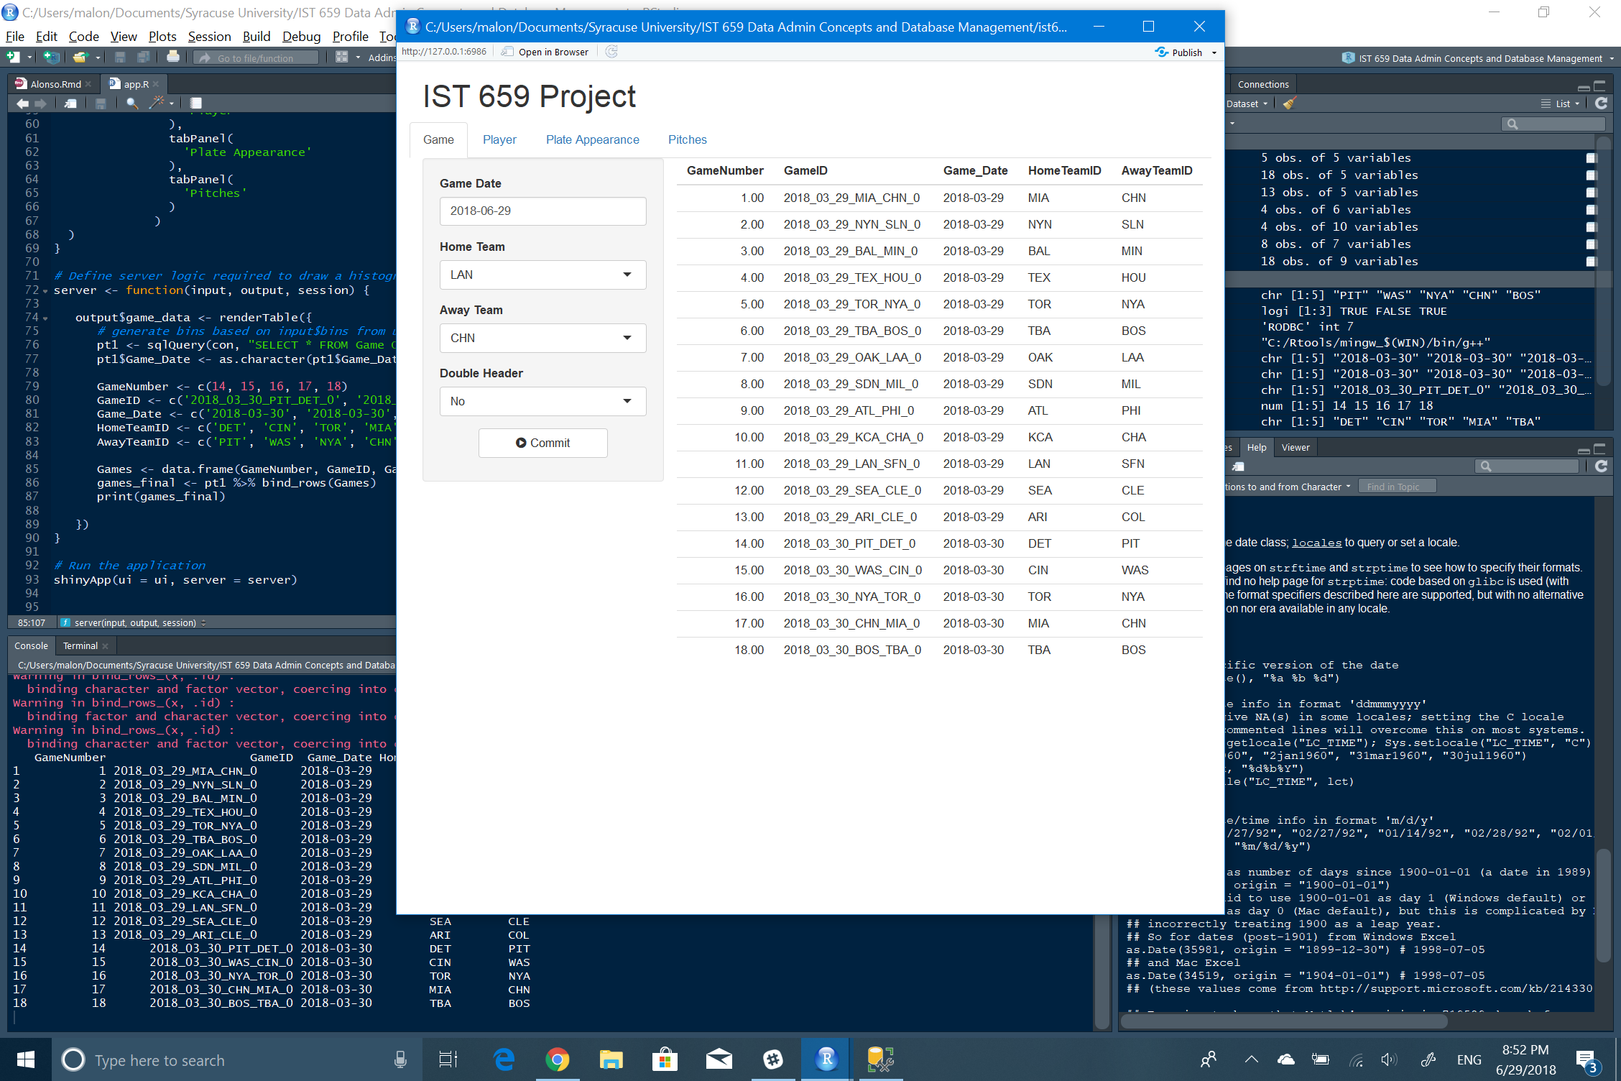

## Insert new player information

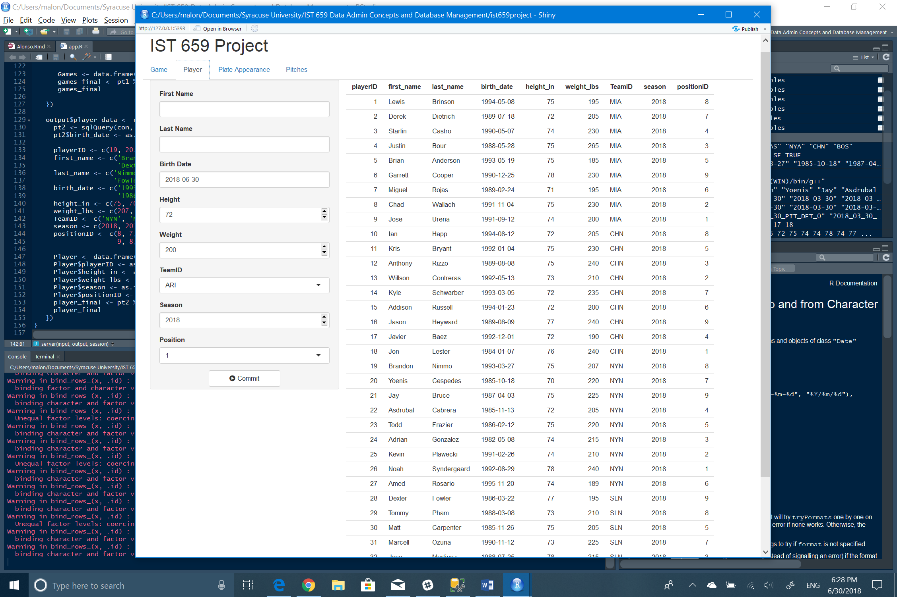

## Insert new plate appearance information

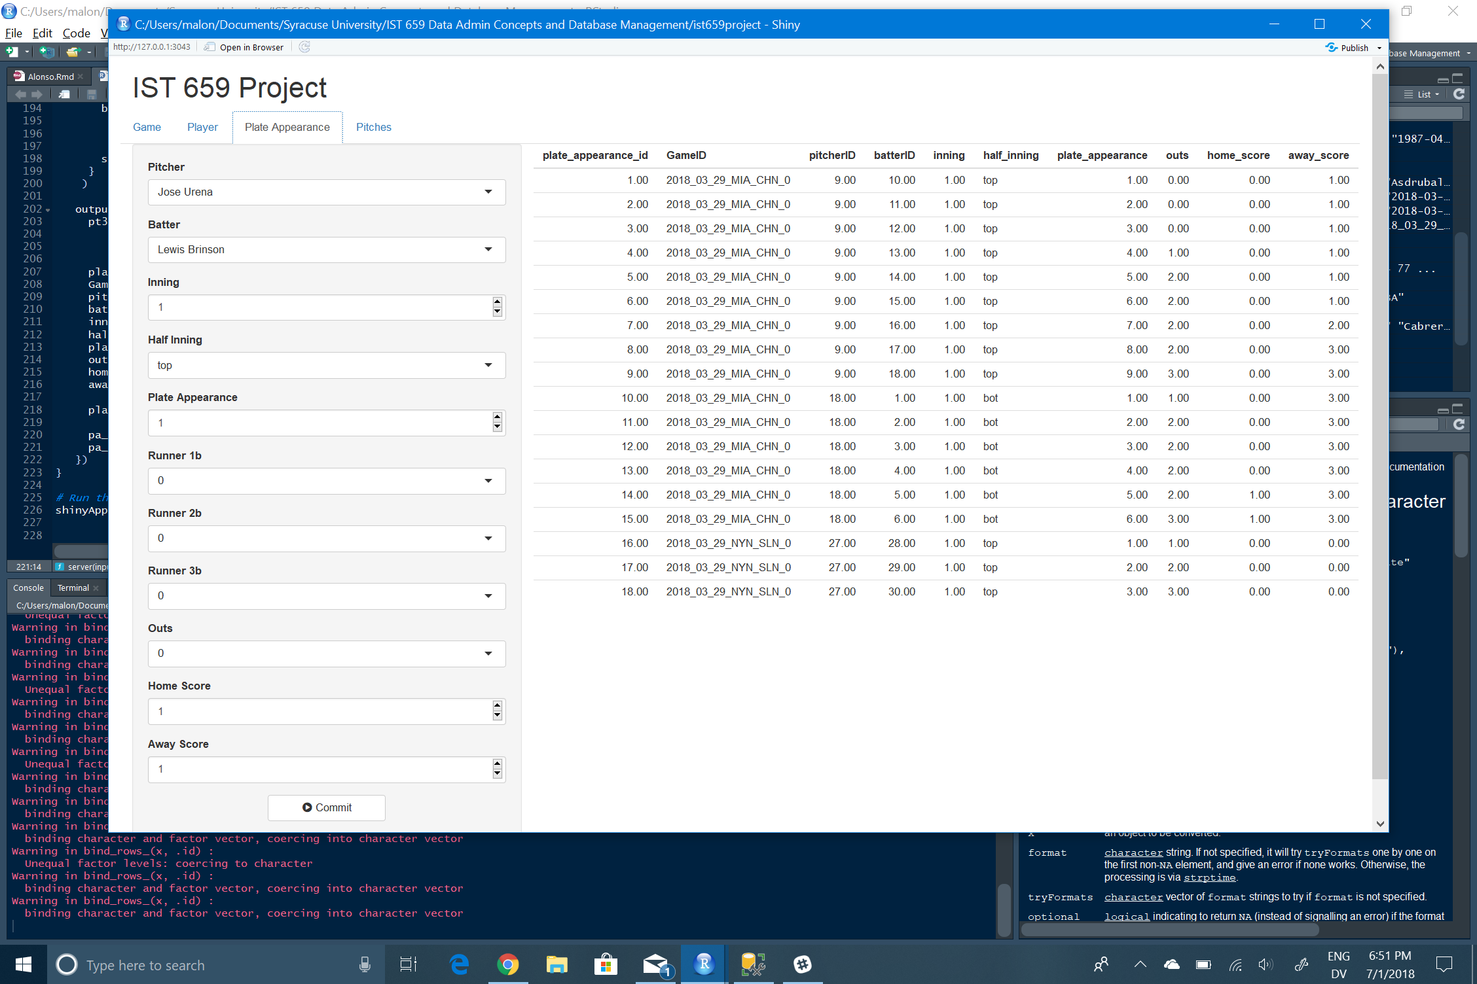

## Insert new pitch information

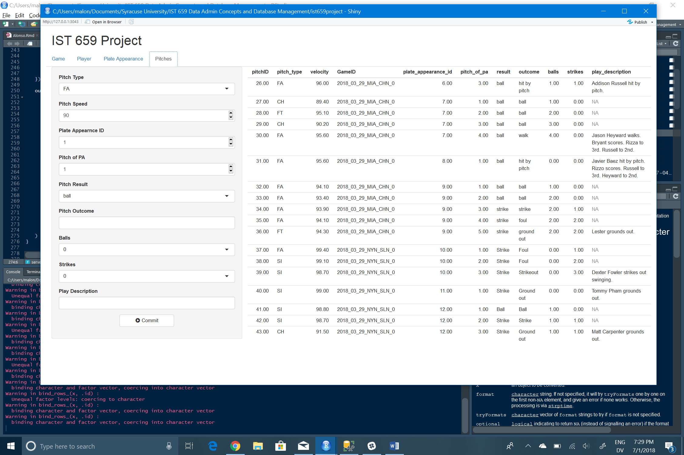

# 9. Reflection

After working extensively on this project, I realize that creating and upkeeping a database is hard work - not as simple as I had assumed going in. I thought I would be able to simplify a series of database tables already in existence, but to my chagrin, I only managed to reduce two tables from the original database tables.  
If there are things that I would do differently, it would probably be on the events table. Though the information is useful to provide context, it could probably be omitted and merged with another of the tables using simplified notation.  
Another thing that I would do differently would be the data insertion. The amount of data in existence is too much and needs to be fed into the tables another way (Excel could be an option, though also limited.)  
Regarding information approach, in future events, the lessons learned lead me to think that this approach is better served by going bottom to top. Once the needs are established, understanding the purpose of the data and how it interacts between itself will help to create better, more robust, and easier to read data tables that - hopefully - will not need extensive joins or many lines of SQL code.